**Web Design Document**

**Designer Name: Adam Abbadusky**

**Domain Name:** [**http://www.adamaportfolio.com/**](http://www.adamaportfolio.com/)



**Hosting Provider: https://www.hostgator.com/**

**Site Goals: Adamaportfolio is meant to promote computer programming work done by Adam Abbadusky in hopes to inspire future employers into hiring.**

**Target Audience: Adamaportfolio is meant to reach future employers for evaluation and other computer programming students to use as an example for their own webpages.**

**Proposed Site Design:**

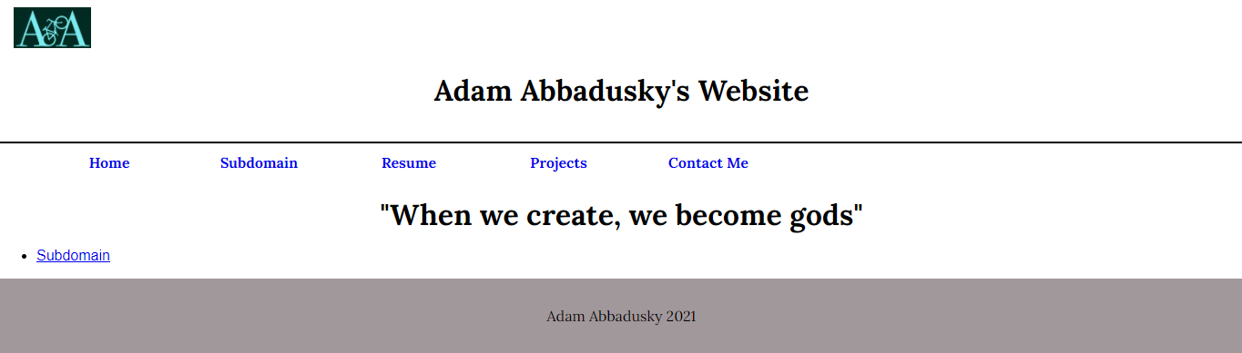

**Proposed Site Features and Functionality**

**Site Map**

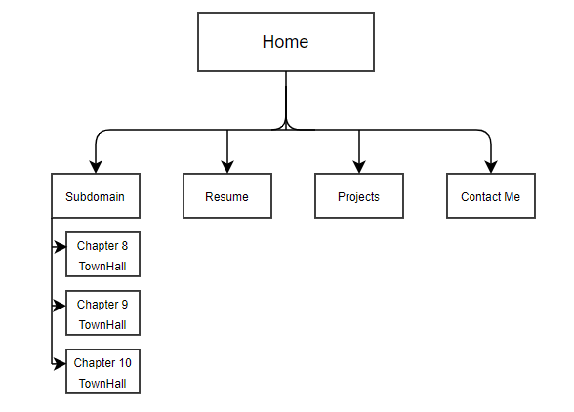

**Home Page**

**The purpose for this page is to show the website template, and summarize what is on adamaportfolio.**

**Subdomain Page**

**The subdomain will take the user to my responsive web designed page to illustrate the different ways I’ve learned to make websites responsive.**

**Resume**

**The resume page will show Adam Abbadusky’s contact information, past employment, and any information needed by someone hiring him.**

**Projects**

**The projects page will show past projects Adam has worked on to demonstrate his abilities.**

**About Me**

**The About Me page will tell information leading to the path of Adam becoming a computer programmer.**

**Wireframe**

**Homepage:**

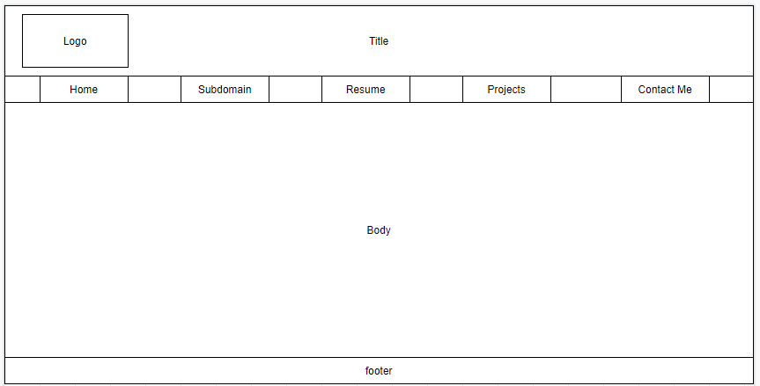

**Subdomain:**

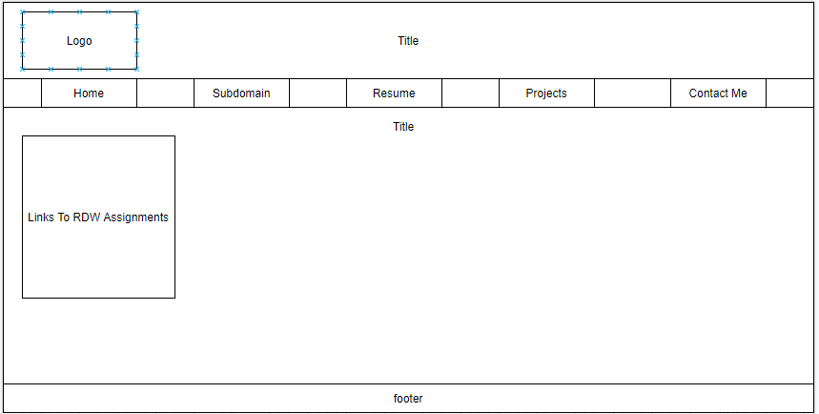

**Mobile Home Page:**

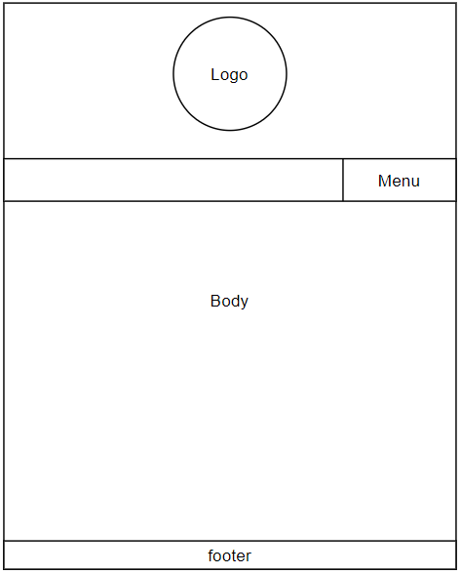

**Menu Navigation Structure**

**Home Subdomain Resume Projects Contact Me**

**Draft Logo**

Reason for logo: Bikes to me represent progress, being able to move forward, and having the freedom to make your own choices.



**Colors:**

|  |  |  |  |  |
| --- | --- | --- | --- | --- |
| Dark Liver | Electric Blue | Black | Fern Green | Myrtle Green |
| #63595C | #7AECF0 | #000000 | #3A7D44 | #307473 |
| RGB: 99, 89, 92 | RGB: 122, 236, 240 | RGB: 0, 0, 0 | RGB: 58, 125, 68 | RGB: 48, 116, 115 |

**Fonts**

**Bodoni 72 Smallcap**

Usage: On logo, and major headers

Link: <https://en.m.fontke.com/font/10593760/download/>

The quick brown fox jumped over the lazy dog

A B C D E F G H I J K L M N O P Q R S T U V W X Y Z

a b c d e f g h i j k l m n o p q r s t u v w x y z

0 1 2 3 4 5 6 7 8 9

¡ @ # $ % ^ & * ( ) - = + / ¿ < >

**Lora**

Usage**:** All basic text inside body

Link: https://fonts.google.com/specimen/Lora?query=lora&preview.text_type=custom&sidebar.open=true&selection.family=Lora:wght@600#glyphs

The big brown fox jumped over the lazy dog.

A B C D E F G H I J K L M N O P Q R S T U V W X Y Z

a b c d e f g h i j k l m n o p q r s t u v w x y z

0 1 2 3 4 5 6 7 8 9

! @ # $ % ^ & * ( ) - = + / ? < >